CMP6200
Individual Undergraduate Project (FYP)
Final Report
New Ways to Play: A Study in Alternative Game Controllers

Student Name: Zorik Rostam
Student ID: 23149743
Course: Bsc (hons) Computer Game Technology
Supervisor: Richard Davies
Date: 5th May 2026

Abstract
The project will be to study alternative game controllers which can shape player experience, immersion and accessibility. Modern controllers such as the PlayStation and Xbox gamepads which have the standard joystick, D-pad and 4 buttons remain the dominant design; however, technology has advanced and companies in the past and future are now developing new forms of gaming that can give players a new way to experience and immerse themselves such as motion-based controllers that offer new opportunities for both developers and players. This study explores the development of a custom Pi Pico-based motion controller alongside a Unity-based game that is mainly developed to evaluate how the hardware-software design can influence gameplay experience.
The project will adapt a hardware-software prototype along with detailed user testing. Which will collect detailed data by using surveys, information sheets and in person tests with permission. The data collected from the users will be anonymised and will collect data purely on the performance of the controller in terms of input accuracy, responsiveness and user feedback on immersion and usability.
This research is to understand alternative game controllers by highlighting key factors like experience, immersion as well as the importance of accessibility, sustainability, and user-friendly experience. It will demonstrate that alternative input systems are most effective when it is purely designed specifically for a game or software where it will excel.

Table of Contents
List of Figures 3
List of Tables 4
1.0 Introduction and Context 5
1.1 Problem Statement 5
2.0 Review of Existing Knowledge 6
Technical Development 6
Immersion 6
Alternative Game Controllers 6
Accessibility 7
2.1 Critical Analysis and Gap Identification 7
2.2 Project Justification 8
3.0 Project Aims, Objectives, and Scope 8
3.1 Project Aim 9
3.2 Project Objectives 9
3.3 Project Scope 9
4.0 Project Design 9
4.1 Design and Methods 10
4.2 Justification of Methods 11
5. Artefact Design 11
5.1 Design Specifications 12
5.2 Artefact's Structure/ Architecture / Framework 13
6. Implementation 15
6.1 Construction of the Artefact 16
Controller Ideas and analysis 16
Tools and Languages 16
Hardware assembly 18
Testing and Refinement 21
Challenges Encountered 21
Artefact Problem Statement 21
6.2 Validation and Testing 21
7. Critical Evaluation 26
Success of the artefact 26
Significance 26
Comparison to similar technology 26
Advntages and contributions 26
7.2 Impact 27
8. Conclusion 27
8.1 Limitations 28
8.2 Future Work 28
Appendices 29
References 31

List of Figures
Figure 1. Components within the Case 12
Figure 2. Design of case with Lid 12
Figure 3. System Architecture 13
Figure 4. FreeCad Case Design 16
Figure 5. Thonny Pi Pico and MPU6050 Code 17
Figure 6. Scene of Match Room 18
Figure 7. Pi Pico WH 19
Figure 8. Soldering Iron Pen 19
Figure 9. BreadBoard 20
Figure 10. MPU6050 / Pins 20
Figure 11. 3D Printed Case and Lid 20
Figure 12. Jumper Wires / Buttons 20
Figure 13. Number of testers 21
Figure 14. Would they use the controller Question 22
Figure 15. Controller Feel Question 22
Figure 16. Controller Responses 23
Figure 17. Controller Improvements 23
Figure 18. Design of the controller 24
Figure 19. Immersion Question 24
Figure 20. Experience and Exploring Questions 25
Figure 21. Gantt Chart Project Timeline 29

List of Tables
Table 1 - Table of Design Specifications 13
Table 2. Key Components 14
Table 3. Technologies and Materials Used 14
Table 4. Risk Assessment and Mitigation 30

1.0 Introduction and Context
This report aims to examine alternative game controllers and their impact on gameplay, immersion and overall player experience. The choice of input device plays a significant role in determining the players’ interaction with a game. (Akyaman & Cem Alppay, 2024).
The project will consist of designing and developing a game alongside a custom controller, both which will continually change and improve throughout the development process. This will help explore how hardware design and the game or software can shape the experience with one another. In addition, this report investigates the role of alternative controllers, primarily motion-based controllers. Particularly how they can affect accessibility as well as their potential to broaden participation for players who may not want to or are unable to use a traditional controller.
Furthermore, the report evaluates the hardware advantages and limitations, such as how this may affect performance and sustainability. It also analyzes how factors such as layout, ergonomics, and functionality influence player immersion and overall usability. The report will also go into detail about the time and development process of the motion-based input device that was being developed for the project.
Finally, the report will also go into detail about the practical development process, including design ideas, planning and time it took. This includes an overview of the tools, materials and technologies used, as well as reflection on the project timeline and the challenges encountered during implementation and providing insight into the integration of hardware and software components and the testing results of the final product.

1.1 Problem Statement
Gaming controllers have always had the expectation to create the standard layout and input methods for most people. But this comes with its own issue where it may not carter to everyone and many players want to explore alternative ways to interact with games to increase their immersion, experience and personal preference. Furthermore, many may be unable to effectively use the traditional controller due to physical limitations. Research indicates that most traditional gaming controllers are not designed with accessibility in mind, making them difficult to use (Malone, et al., 2023) and potentially losing out on a wider range of players.
This highlights the gap in the market which creates a barrier to entry for small studios and developers to create alternative controllers and address the solution for accessibility and immersive gameplay by being able to feed into the needs of the consumers that can support a wider range of players while still maintaining effective gameplay interaction. This project aims to study and address the issue by developing a custom controller that will be designed along with a game environment, enabling a more interactive and integrated player experience.

2.0 Review of Existing Knowledge

Technical Development
Alternative game controllers have been around for many years from the popularity of motion controls such as the Nintendo Wii and Kinect to more advanced technology like Virtual Reality which allows the user to essentially be in a world of their own which can track full human interaction. A lot of these alternative game controllers still use the traditional buttons and joysticks, but more have started using as little as possible and mostly dependent on motion control and non-traditional inputs.

Immersion
Immersion refers to a person having full engagement on the task they are focused on. This can be related to the project because players can be so immersed in the game, they can lose track of time and lack awareness of real-world time and surroundings. There are different forms of immersion such as sensory, challenge based, narrative immersion etc. But the form of immersion that will be focused on in this report will be how alternative game controllers can help with the players’ experience and immersion within video games. Research into motion controls has shown that players are prone to respond more positively when the controls they are using feel more natural for the game that makes sense. For example, for sports games and possible arcade shooter style games players prefer to use motion-based controls rather than having the traditional button and joystick layout. However, poorly implemented motion controls can lead to frustration and reduced enjoyment if the controls do not appropriately match the gameplay experience. (Madigan, 2015)

Alternative Game Controllers
Immersion is a focal point in the game industry whether that's how often players can turn their devices on to play a game or how long they can sit and play.
Games that want to offer a high degree of immersion have taken this into consideration. The XBOX 360 gamepad and the Nintendo Wii remote were judged for bringing little change to immersion, even though the Wii remote was such a new and revolutionary tech at the time for video games which was meant to makes use of motion control that is meant to increase player experience and players within the game which for a lot of people it did. (Thorpe, et al., 2011) . These are aspects that a lot of game studios have in mind when developing their games. There is also the physical form equipment that contributes to these forms of immersion for players, and one of the most important aspects is the input system that allows players to be immersed in the games they play. Having a comfortable controller is just as important as being able to play the game.

Accessibility
Many of the people that enjoy games also look for controllers that may give them a separate experience from the traditional layout that exist. Because they want to feel like they are part of the game having a controller that supports motion-based controls or any other form of control aside from the regular joystick and buttons can drastically improve experience. Furthermore, a lot of players may not even be able to use regular controllers so have alternative controllers that will give them access to still enjoy any game is an important consideration.

2.1 Critical Analysis and Gap Identification
This report so far has covered alternative game controllers and how and why they are used to potentially improve player experience and immersion. However, using reports to support these statements, it is clear to see that these studies fail to explore how alternative game controllers could potentially have risks or failures, and how alternative game controllers affect the game they play and why it may ruin the player’s experience.
However, the identified key gaps in research are:
    - The potential for risks that people may suffer from these alternative game controllers.
    - The lack of consumer needs most people prefer to use regular gamepads instead of alternative game controllers like motion controls when gaming.
    - Players’ early frustration when using alternative game controllers, and how they may not be familiar using the hardware.
    - Research often assumes players with full range of motion or perfect vision and hearing.
    - Environmental impacts and how creating these alternative game controllers may cost a lot to produce and contain a lot of unnecessary materials.

The gaps within the research on alternative game controllers have many similarities and the research suggests that a lot will need to be considered when

developing the hardware and can make the player experience much more immersive and much better experience overall.

2.2 Project Justification
It is important to build on the gaps that are in the research such as lack of studies on environmental impacts, potentially wasting materials to produce these high-end hardware and cost of production. Players that use these alternative controllers, such as VR or motion controls, may feel frustrated because they may not know how to use them or even players who may not know some of the limitations that come with some of the hardware, and may not be able to fully use these functions. Furthermore, accessibility plays an important role in being able to identify and take action to produce a product where anyone can use an alternative controller to experience games, is just as important.
The core idea behind the project, which will fill in the gaps, will be a controller that will be developed to be a part of a game and will be developed alongside each other. This will ensure that the controller works effectively and can help players understand the hardware behind these features such as motion controls that can support players who may not be able to or want to use the traditional joystick or button on gamepads. The gaps that are in the research will be eliminated by ensuring reduced costs. Also, reduced materials will be used during the development of this project. This will be achieved by using a Raspberry Pi Pico W and an MPU6050 which will help produce a motion-based controller to showcase how motion-based controls work as well as the advantages and disadvantages.
The project outcome is that it can help players learn and understand how to use some of these alternative game controllers and be ready for future hardware such as VR, Motion controls, etc. which will help other companies potentially increase their consumer numbers and reach a wide audience. They will be more aware of the hardware capabilities and potentially encourage other large corporates to do their own further research into the gaps missing within their own studies.

3.0 Project Aims, Objectives, and Scope
During this project there will be aims, objectives and scopes that will need to be followed to ensure the project goes all as planned. This will be done with bullet points in each section showing what will be done to ensure the best possible result for the overall project success.

3.1 Project Aim
The aim of this project is to develop an alternative game controller which will be motion-based, as well as a game within unity that will support the controller to help capture the mechanics and how alternative controllers can work and be beneficial.

3.2 Project Objectives
- Objective 1: Research focused to establish knowledge foundation
- Objective 2: Technical implementation building the input system
- Objective 3: Gameplay design integration, creating the game around the input system.
- Objective 4: Prototype completion, have a playable build
- Objective 5: User testing and evaluate experience
- Objective 6: Analysis and documentation

3.3 Project Scope
This project will concentrate on alternative input methods which will help the user capture the full experience of the hardware, such as motion control. Another focus will be researching and prototyping while also developing a game that will help understand this hardware. This project will not be developing multiple input systems or full-scale commercial games. It is purely for analyzing how alternative game controllers can shape player experience and immersion and improvements that can be made.

4.0 Project Design
The steps that will be taken is very simple; the product will be a fully working controller along with a game to study alternative game controllers. This will be done by using the current knowledge I have of this study as well as the skills I have learnt to design and develop to bring the best possible results. During the project there will be phases that will keep everything organized and on track. This will be done by using tables and notes like Gantt Charts, GitHub version control, Kanban and appropriate planning. The tools used will be purchased online as well as the parts required to build the controller but to build the controller heavy planning went through ahead of time so that the project didn’t go over budget as well as the best possible results. In addition, software tools that are free such as Unity and Thonny will be used to develop a game that can simultaneously work with the controller to showcase its capabilities.

4.1 Design and Methods
The overall approach to this project will be taken very cautiously and will involve multiple experiments and development phases which will help produce the best results. Designing and prototyping an input system game controller along with a software integration will clearly demonstrate the results of the alternative game controller.
Development of the Unity game will be used as a test environment.
The aim is to evaluate player immersion and experience using the custom designed controller this will be done through multiple in person tests where the players will use the controller as well as take part in an online survey which will help gather results. Even though the project requires a functional build of the input system and unity game, the results still require statistical analysis and data gathering to show the project works and provides the required goal to achieve immersion and player experience.

This project will involve gathering data such as quantitative data like response times, reliability, number of successful inputs. Data qualitative data will also be used, such as user feedback, observation notes about how the player felt and the ease of use and immersion. Design data will be considered, determining if the input system writing schematics are effective and ensuring the sensor calibrations and ensure Unity input mappings are correctly working as intended.
When designing and building the custom game controller, the Raspberry Pi Pico W for prototyping will be used, as it effectively gives all the parts required to design this project, offering a variety of wires, sensory technology, circuit design on breadboard and code in Thonny.
Along with the game controller, the Unity-Based game will be needed to work simultaneously along with the custom based controller using Visual studio C# and Thonny to create gameplay responding to the inputs. Using custom input mapping with Unity built in Input Map should help with connecting the hardware signals to in game actions.

4.2 Justification of Methods
The approach that has been decided during the development of this project has been picked out carefully to ensure the best possible results. Having players be able to test the controller in person with the game that has been made will be a great way to have accurate and precise feedback which will be evaluated, furthermore having play testers take part in an online survey right after will ensure a highly accurate data collection and responses. Having physical one to one testing’s where the project can be seen completed by a person without any altering answers or fake feedback is a much better way to test especially for the controller, if the tests were done online the testers would not be able to use the controller as well as non-accurate data because testers may alter answers online and unreliable people.
In addition, using the Raspberry Pi Pico is a reliable and cheap product along with the MPU6050 to ensure a cheap and simple motion-based controller to showcase the capabilities of alternative game controllers. As well as choosing to develop the game using Unity and C# because of its ease of access and knowledge required to develop.

5. Artefact Design
The artefact design was inspired by the WII remote it is essentially a handheld device that is placed in a rectangular 3D printed case with the top being a separate part that sits on top to cover the components within the case. The case has rounded corners with smooth surface to ensure the user is comfortable when holding the controller.
For the controller I decided to use green tapes to connect the case and the lid together to give ease of access to the inside components for replacements and upgrades as well as give a simple design such as improved grip so the device can be stable when moving around and holding. As you would hold any other remote the thumb naturally rests on top of the case where the button is just a little bit above the middle of the case.
The case was designed using a software called FreeCad and the material used was a green PLA filament through the Bambulab P1s 3D printer using a 0.4 mm nozzle. The inside of the case contains the electronic components such as the breadboard, Pi Pico W H and the MPU6050. The overall shape of the case was designed with the intention of it looking like a remote and support the use of one-handed motion control as well as it being portable to carry around.
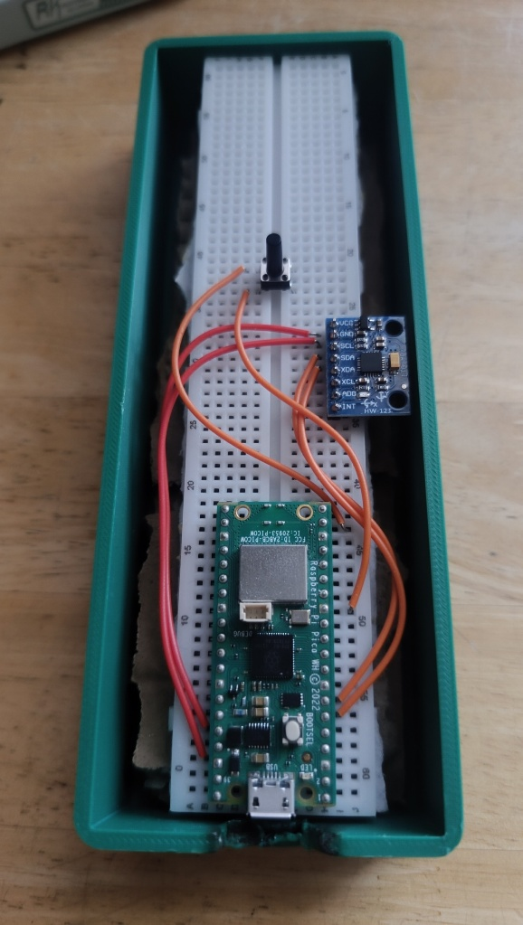
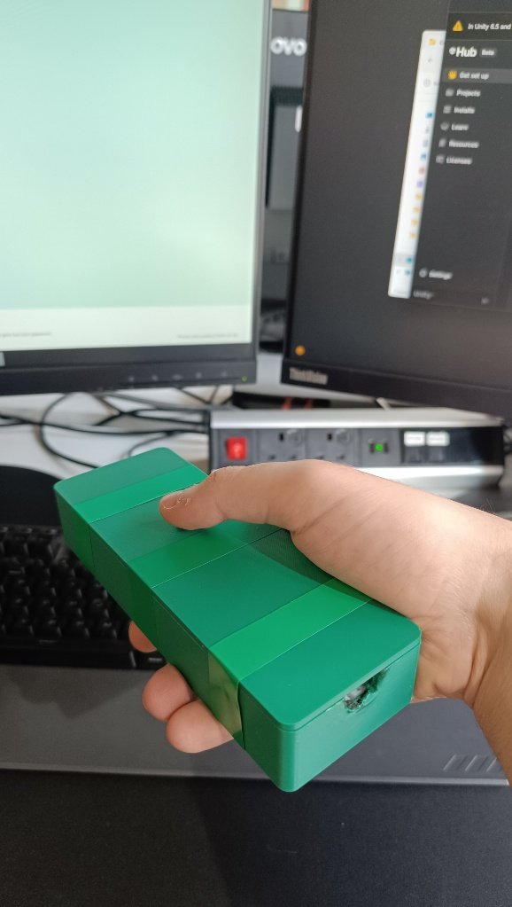
Figure 1. Components within the Case
Figure 2. Design of case with Lid

5.1 Design Specifications
Specification | Requirements / Constraint
Portability | The artefact must be compact and lightweight enough to be comfortably used with one hand
Ergonomics | The design must allow a natural thumb position and secure grip when holding the controller.
Durability | The case must protect the internal electronics from impacts and handling.
Material | The casting must be manufacturable using 3D printing with PLA filament.
Size Constraints | The artefact dimensions must fit within the available 3D printer build size.
Internal Space | The enclosure must provide sufficient room for the internal electronics and wiring
Accessibility | The design must allow access to charging ports or internal components for maintenance
Safety | Sharpe edges and exposed wiring must be avoided during normal use
Usability | The device must support simple one-handed interaction
Manufacturing | The design should minimise print complexity and material usage.
Table 1 - Table of Design Specifications

5.2 Artefact's Structure/ Architecture / Framework
The artefact is a handheld motion-controlled device designed to work as a HID (Human interface device) for controlling the computer mouse cursor. It consists of a 3D printed Case for the controller with hardware such as the Pi Pico WH, MPU6050 and jumper wires to connect to each other as well as a 6x6 button to function all together. The case provides support for the components to keep it well protected as well as a comfortable shell for the player to hold.
The Pi Pico uses Thonny as the python programming language and tool to ensure it can read and connect with the MPU6050 giving the ability to motion control the computer cursor.
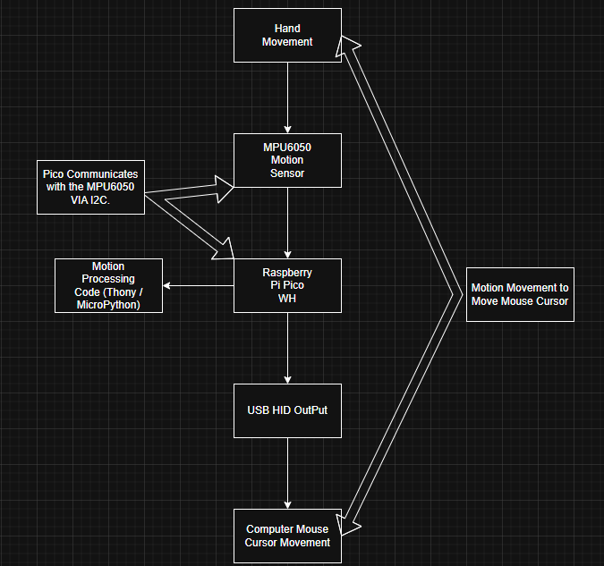
Figure 3. System Architecture
Components | Function
3D Printed Case | Places the components inside and protects internal components while still allowing ergonomic handling.
Raspberry Pi Pico WH | Main Controller for processing sensor data and generating HID Mouse output.
MPU6050 | Registers acceleration and rotational movement of the device.
Breadboard | Provides for circuit connections
Jumper Wires | Connect electronic components together
6x6 Push Button | Used for clicking and interaction
USB Connection | Supplies power and transfer HID data to the computer.
Soldering Iron Pen | To connect the pins to the MPU6050
Soldering Iron Metal | Filler metal to join parts together when melting with the Soldering Pen
Table 2. Key Components
Items | Technology / Material
Controller Case | PLA filament manufactured using Bambulab P1S 3D printer
Programming Language | MicroPython (Thonny) and C# (Visual Studio)
Motion Sensor | MPU6050 Accelerometer and gyroscope
Communication Method | USB HID protocol
Embedded System | Raspberry Pi Pico WH Microcontroller
Table 3. Technologies and Materials Used

The MPU6050 constantly measures movement and orientation when the player moves the controller, this data is transferred to the Raspberry Pi Pico WH through wired connections on the breadboard. Connecting the VCC, GND, SCL and SDA from the MPU6050 to the Pico Board which are 3V3 (pin36), GND (pin38), GP4 (pin6) and GP5 (pin7).
The MicroPython Program that is installed and running on the Pico WH ensures it reads the sensor readings from the MPU6050 and converts them into cursor movement. This data is transmitted to the computer through a USB type B essentially allowing the device to control the cursor movement using motion control. Furthermore, the 6x6 push buttons which were connected using the pins 13 and 19 allows for the player to click the button to interact like a mouse click. This case has been designed to fit the device inside it and the interaction with button and USB to feel seamless.

6. Implementation
The implementation process had multiple phases such as planning, discussing with the supervisor on a weekly basis, research as early as possible so that the correct components were purchased to assemble, program and test the motion-based controller with the game being designed.
The project started with deep analysis, research and planning about alternative game controller, knowing which steps to take to design the artefact and how to present it. Using a Gantt Chart as well as the kanban on GitHub it allowed for clear tracking and planning, starting with researching the type of module kits that allowed for motion tracking because that’s what the project was decided on to create a controller that allowed for motion tracking, easy to use and accessible to anyone. Furthermore, also looking into the game engine and programming language to use to design the game environment to test the controller which ended up being Thonny as the controller programming tool and Unity/C# to develop the game.
The motion-based controller went with multiple tests to ensure that it worked with the game, having it first running using an internet connection but later realising to make it more portable the controller had to be further improved to mimic a mouse which will allow it to create a custom device. This was done by switching the Raspberry Pi Pico to use CircuitPython which allows for easy HID support.
Several stages of testing and validation were completed throughout the development. The first stage of testing was ensuring the Raspberry Pi Pico WH and the MPU6050 worked together. Sensor readings were monitored using Debugs in Thonny to confirm accurate motion. Further testing ensured that the responsiveness of the controller was improved to give the player accurate movement and less drift. The 3D case was also designed with the intention of protecting and fitting the controller components inside and giving the player comfortable device to hold.
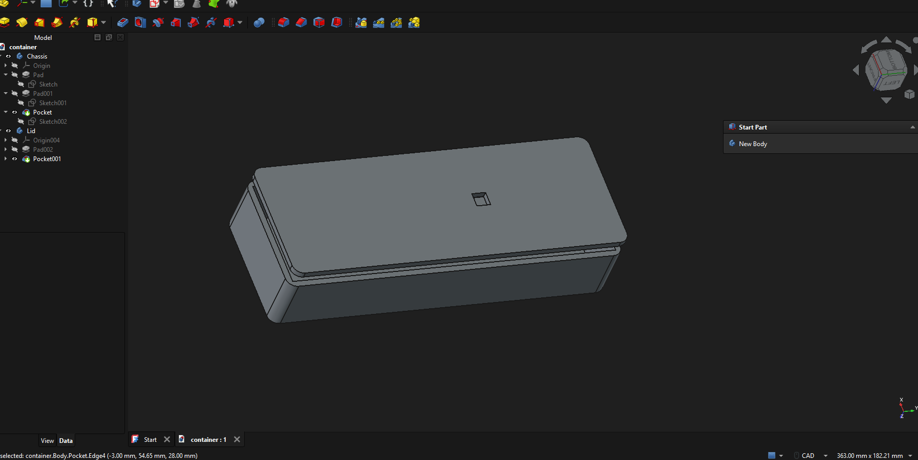
Figure 4. FreeCad Case Design

Final validation and testing involved the artefact fulfilling the project aims and objectives of enabling a motion-based controller that could control the cursor through handheld movement. As well as the controller working in custom based Unity game that allowed the player to play a game using the device.

6.1 Construction of the Artefact

Controller Ideas and analysis
The construction of the artefact involved multiple stages of purchasing and putting together components for both hardware and software. For the controller the first idea was to create a glove with the components on the gloves which meant having to move your whole arm or wrist for motion but after further discussion and analysis that could end up being very ineffective and could lead to arm tiredness and other problems like components not having solid protection. So, the design was changed to be more of a regular controller like the Wii remote or any other TV remote so the player could hold it in their hand and comfortably move it around however they want and just place it down without having to put anything on.

Tools and Languages
The tools that were used during the project were Unity because of its simple and easy to use for game development as well as C# because of prior knowledge and recommendations when building a game especially for an alternative game controller. For the controller itself Thonny python programming was used to ensure the Pi Pico WH and the MPU6050 communicated together and worked as a HID system. 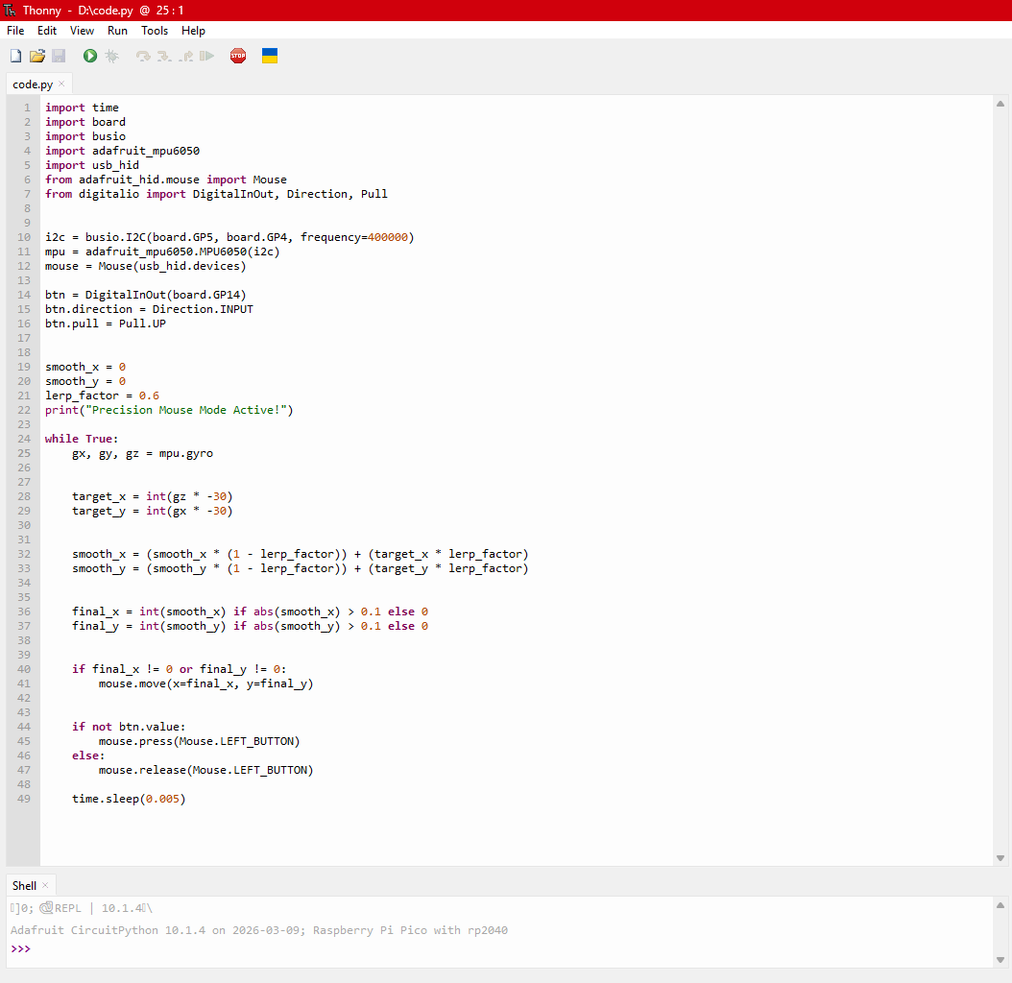
Figure 5. Thonny Pi Pico and MPU6050 Code

The MPU6050 uses a gyroscope sensor that is essentially connected via I2C to detect any movement of the device. Essentially the gyroscope readings are from the gx, gy, gz = mpu.gyro, so to correctly calculate the movement of motion using target_x = int(gz * -30) and target_y = int(gx * -30) the processed movement data is transmitted to the computer using the USB type A cable to emulate the cursor. Which is essentially how we get the correct motion logic when the player moves the wrist up/down the cursor will on screen goes up/down and same applies with left and right.
In addition, to improve the cursor stability and reduce the sensitive reads from the gyroscope a lerp was implemented. This would help give a more smooth and stable cursor movement and more accurate. A dead zone threshold was also implemented to stop any small movements by gyroscope readings so when the player wasn’t moving the controller there would be no unnecessary movements.
A 6x6 push button was also connected to the pins 13 and 19 to allow power and connect. A simple logic that allows for the player to interact like how a left click on a cursor would work.
For the unity game using C# for the scripts a simple arcade shooter game was developed to showcase how motion controls can be used and having a shooting mechanic where aim is important can showcase the controls of the motion-based controller and stress test as well as see how accurate it can be. This was done by having the player shoot at 3 enemies and defeat them before the enemies take the players health down to 0 this was the simple game logic and a good environment for the motion-based controller.
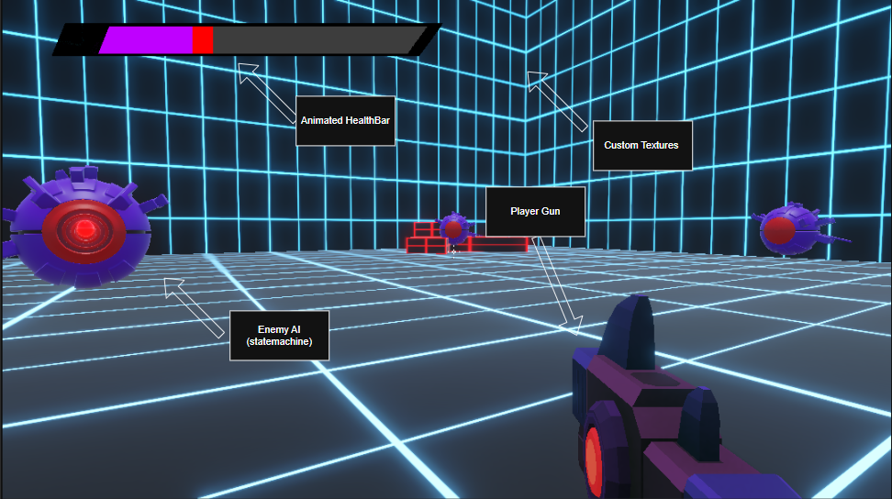
Figure 6. Scene of Match Room

Hardware assembly
After purchasing all the required items such as the breadboard, Flexible jumper wires, 6x6 buttons, Pi Pico WH and MPU6050 the production of the controller began. Starting with the breadboard placing the Pico and ensuring it is securely placed on top, once that was completed soldering the pins to the MPU6050 and placing it on the breadboard to ensure stability for powering the device as well as keeping it secure on the controller. Lastly placing the buttons on the breadboard as well, once everything was set, all the flexible jumper wires were connected from the Pi Pico to the buttons and MPU6050.
Choosing the MPU6050 because of its cheap price as well as ease of use containing the ability for an accelerometer and gyroscope within it allowing for good readings of movements. The raspberry Pi Pico WH was chosen for its low cost and programmable USB HID technology, small size and MicroPython compatibility.

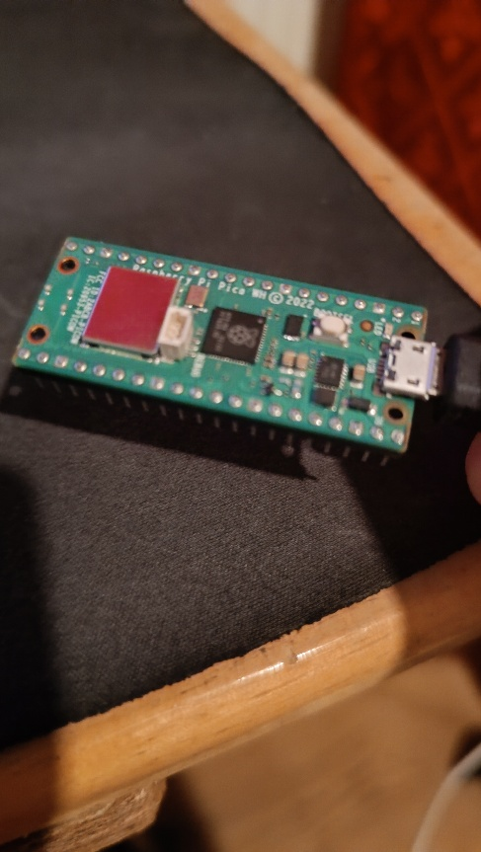
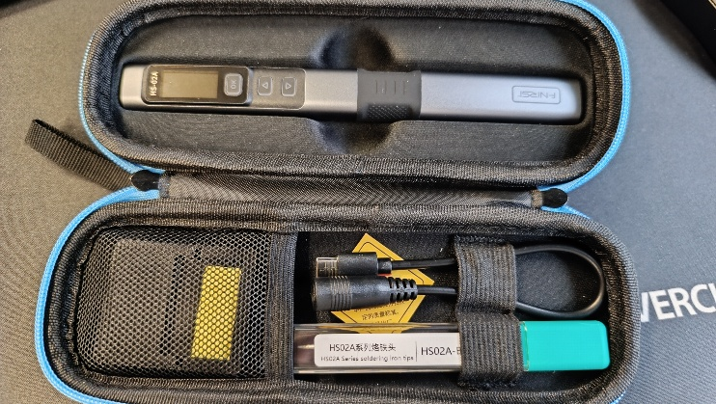
Figure 7. Pi Pico WH
Figure 8. Soldering Iron Pen

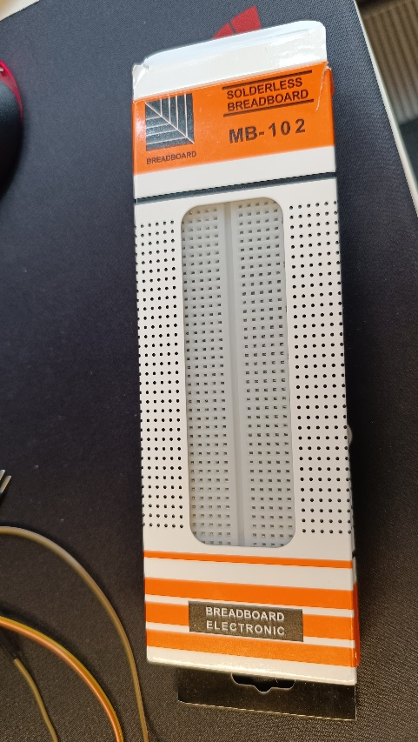
Figure 9. BreadBoard

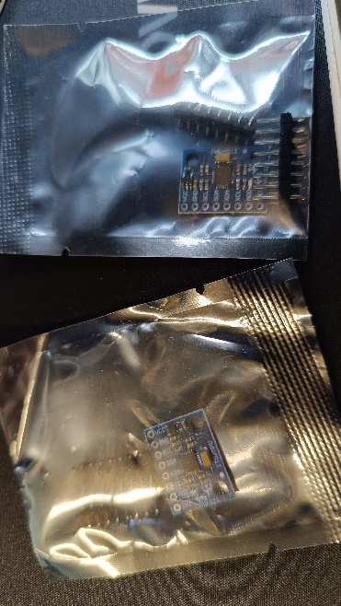
Figure 10. MPU6050 / Pins

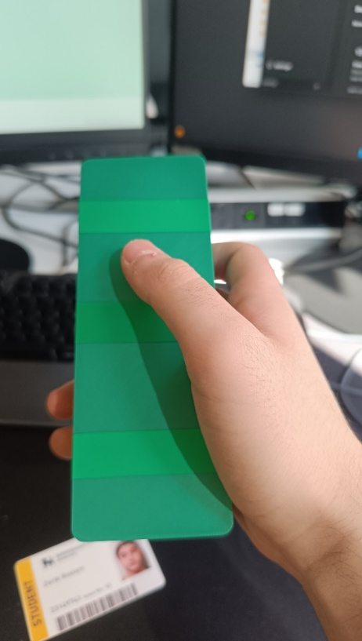
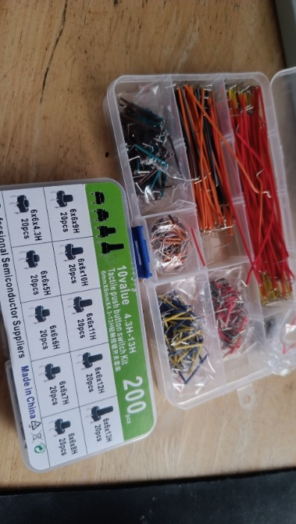
Figure 11. 3D Printed Case and Lid
Figure 12. Jumper Wires / Buttons

Testing and Refinement
Multiple tests were done to ensure that the controller was well connected physically and software, ensuring the cables were well connected and didn’t go lose when the player would use motion control. Furthermore, testing was conducted so ensure the controller worked as fast as possible reading data accurately.

Challenges Encountered
Some of the problems that was encountered was the lack of removing delay within the controller so when the player moved the controller to far the cursor would be the same on screen but the controller would be in a completely different direction so the gyro was off centre, this is due the limitations of the MPU6050 being an older hardware high latency and drift.

Artefact Problem Statement
Going back to the introduction there were a few things that the artefact was supposed to address such as the hardware advantages/disadvantages, does it change the players immersion and experience, the performance of the controller was it sustainable and ergonomically usable. This will be talked about further into detail in the next few sections. But to simply explain the controller design was good, but improvements could be made, the button could be changed to be much larger and more stable, as well as fixing the delay and drift when moving to far and some players found the controller to be fun.

6.2 Validation and Testing
Multiple tests were performed keeping the data anonymous the testers were sat down and read an information sheet about the project as well as signing a consent form to inform that they agree with being a tester. Once the documents were read and signed, they were given the custom based controller and the game to play after testing they would also be required to take part in an online form which would have a variety of questions as well as opportunities for them to give thoughts about the artefact.
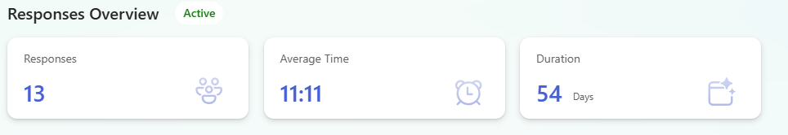
Figure 13. Number of testers
There were questions based on the controller as well as the game where the controller was tested in, but the main results were from the questions surrounding the motion-based controller and how those results could be helpful to understand alternative game controllers. One of the questions were “would you use this motion-based controller instead of a traditional one?” and the results were split but most the testers went with depends. 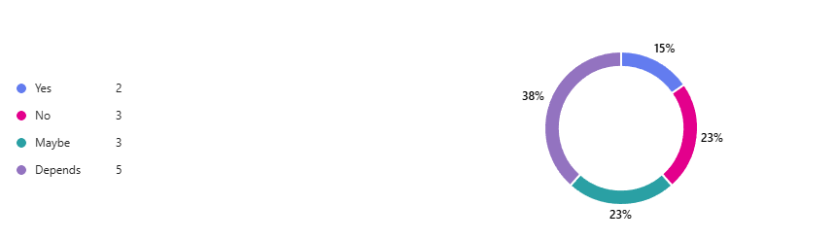
Figure 14. Would they use the controller Question
A lot of the answers were that it would depend on the game they would play and if it makes sense, this could be related back to an earlier in the immersion section of the report where it would be beneficial if the game that players played would have supported for the controller and give them an advantage or make it fun to use. So alternative game controllers are usable, and players do like to use them, but they would need a motive to use them.
The next set of questions are mainly about the performance of the controller. “How do the controls feel overall?” 46% said that the motion-based controller was okay because of the delay and drift that the gyro had when moving to far from the screen and this would mean the controller wouldn’t be correctly moving the cursor on screen and making it awkward. 38% said that the controller was smooth based of startup movement the gyro wasn’t always off centre and for the most part the controller responded to fast movement and was accurate when moving.
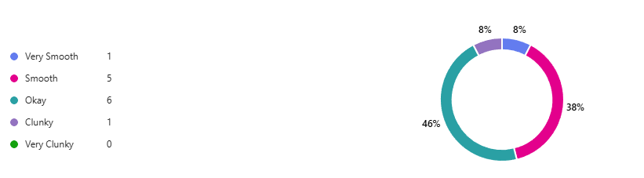
Figure 15. Controller Feel Question
The next question was “how responsive are the controls? 1 being not at all and 10 being very responsive” And the average rating of this was higher than expected with a 7.58 Rating out of 10 which shows the controller for the most part is very responsive and with further upgrades could be improved. 100% of the testers all said that the controls were very easy to learn.
A lot of the testers also thought that the controls were good and well-made but common answers like the gyro seem to be misaligned when moving too much, and once they learnt the recentre mechanic that was implemented to help with the gyro delay and drift it made the experience better. But fixing these issues could potentially improve the experience even more.
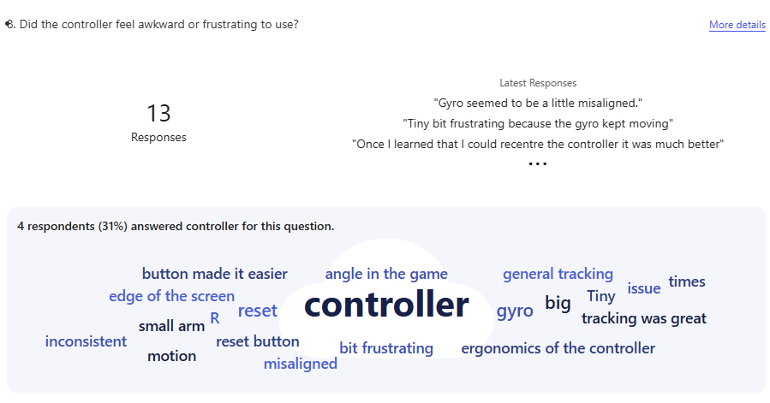
Figure 16. Controller Responses

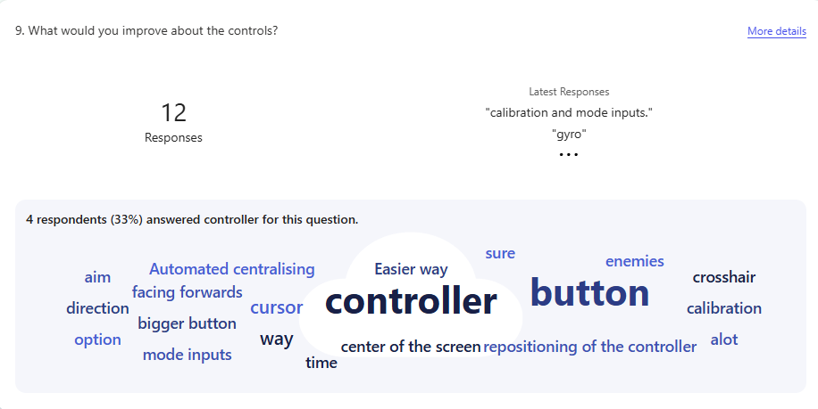
Figure 17. Controller Improvements
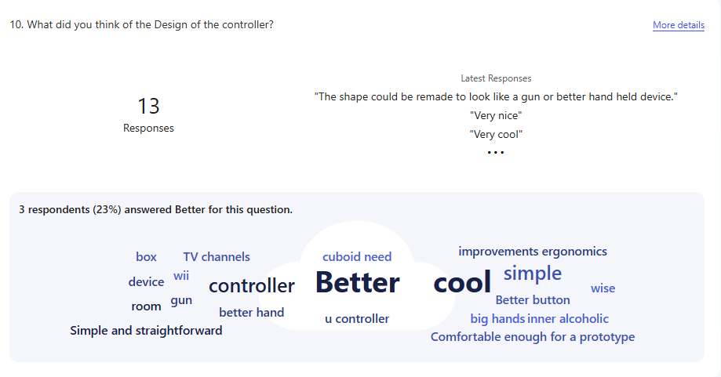
Figure 18. Design of the controller
77% of testers said that they were somewhat confident using the motion-based controller and the other 23% said they were extremely confident indicating people are aware of this technology and with further improvements the controller can be really fun to use further implying that companies should invest into alternative game controllers as there is a massive group of players in the market that enjoy and it is still on the arise. The average rating overall from all testers came to about 7 /10 being the performance of the controller with the game was very good and the environment to test the controller was excellent.
The next question is very important as it allowed to answer one of the main questions in this research and that’s if alternative game controllers can help shape player experience and immersion and 69% of the testers said that it did feel immersive.
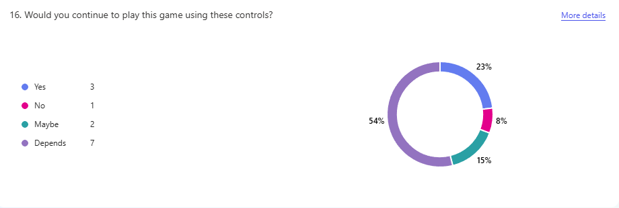
Figure 19. Immersion Question
A lot of the testers said that they would consider exploring alternative game controllers. And that overall, the experience using a custom motion-based controller was 3.82 out of 5, showing that the controller did improve the game for them and that it was very impressive and once the issues were fixed it has massive potential to be extremely fun and useful in a lot of games.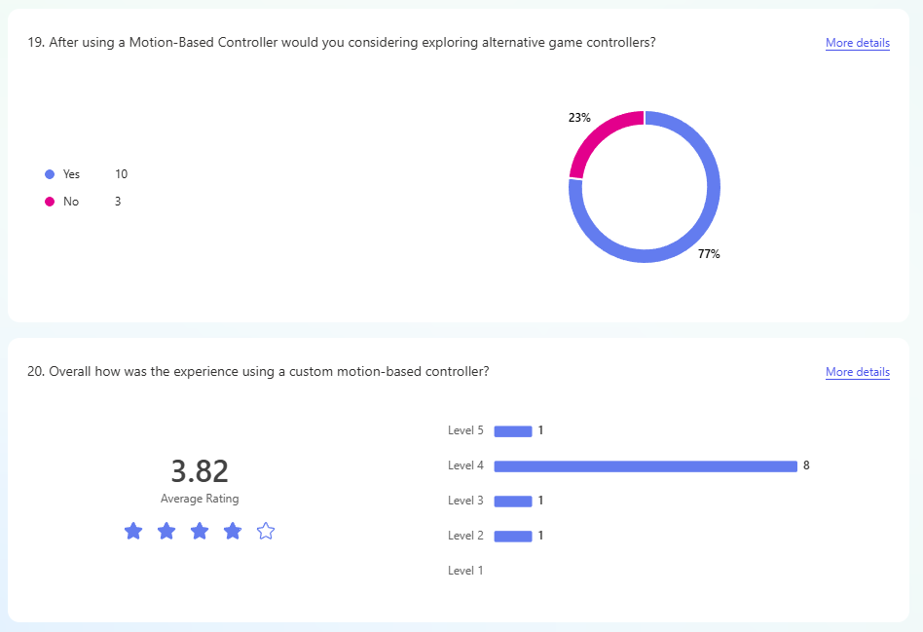
Figure 20. Experience and Exploring Questions
Lastly the final question was based on what the testers thought they could improve or change after using the controller in game. 44% of the testers said that the button could be improved to become more stable as well as bigger to feel more like a controller as well as reduce the size of the 3D printed case and of course improving the gyroscope to become more accurate and less drift.
Overall, the tests confirm that the motion-based controller is both functional and fun to use answering the questions that was researched about alternative game controllers and the artefact itself was designed well to work with the game environment that was created. While there were some limitations and improvements like the gyroscope and controller design, they did not prevent the testers from using it effectively. Instead, they show further future improvements and the advantages of motion-based controllers and alternative controllers.

7. Critical Evaluation
The artefact is a handheld motion-based controller that allows the user to control the cursor on screen from any laptop or desktop using physical movement. It uses an MPU6050 gyroscope & accelerometer and a Raspberry Pi Pico WH to detect and process the motion with a button for additional input.

Success of the artefact
The artefact was successfully completed and was able to achieve its core objectives. Testing showed it was functional, responsive and easy to learn with most testers agreeing that it improved player experience and immersion and they were able to use it effectively.

Significance
The artefact is significant as it helps understand a new way to play with alternative game controllers, it effectively demonstrates that motion-based controllers can enhance and engage player experience and immersion. In addition, it can also show that these systems can be developed using low-cost, accessible components to help stop damage against the environment and help players who may want to use this technology to help them game if they are not able to or want to use traditional controllers.

Comparison to similar technology
The artefact compared to commercial technology shows that its more affordable and flexible to build and use, working as a general HID system. However, it lacks the precision and advanced calibration that are found in VR systems and other alternative game controllers because of less components and cheaper options resulting in lower accuracy and drift issues.

Advntages and contributions
The advantages of the controller are that its low cost and easy to setup, supports easy immersive interaction, its portable and customizable and can help players who want to experience or those who may not be able to use traditional controllers easy access to alternative controllers to use. The main contribution was to create an easily accessible alternative game controller for everyone showcasing that you don’t need to spend a lot of money, gives players who want and need alternative game controllers and still function effectively.

7.2 Impact
The artefact has potential impact on gaming in a whole massively changing how the player can play games clearly demonstrates the uses of alternative game controllers. It addresses the need for more immersive and engaging experience, especially for people who want to use something else but the traditional controller or keyboard and mice setup.
For many people seeking alternative game controllers means having a more interactive and physical way of playing video games. The test clearly shows that users are open to using alternative game controllers if it feeds their needs as well as helping people who may not be able to use traditional controllers or inputs because of limitations or disadvantages so having a controller that doesn’t require much where they can still feel immersed and have fun like anyone else is important.
From the industry view, the artefact shows the constant trends towards alternative game controllers especially motion control and immersive technology. Demonstrating that the artefact can be developed almost the same way but just much more cost effective and more accessible.
The artefact brings a new perspective to academic discussions as it contributes to usability and motion tracking technology and providing practical evidence and clear study and research into alternative game controllers. And identifying the clear issues with using cheap components such as drift and calibration challenges.

8. Conclusion
The project aimed to investigate whether a new way to play with alternative game specifically motion-based controllers could provide improved immersion, player experience and accessibility compared to traditional controllers. The problem identified was that most standard controllers do not always support for all players and don’t meet expectations and limit immersion and accessibility for some users.
To address this, low-cost components were purchased to develop the motion-based controller and specifically designed in a way that it could be supported and tested in a Unity based game for the controller to showcase the capabilities and functionality. The project followed a structured approach with in-depth planning, research, design and development for both hardware and software and with clear user testing.
Overall, the project can be considered successful as it met its core objectives and demonstrated that motion-based controllers and alternative game controllers alike can provide an engaging and immersive experience to traditional controllers. As well as giving great data on players thoughts on alternative game controllers for future research and development.

8.1 Limitations
This section lets you demonstrate critical self-awareness by honestly acknowledging your work's boundaries and constraints. For example, did your chosen method have any weaknesses? What did you have to leave out? What are the practical weaknesses of your artefact? Or was your dataset small, incomplete, or biased in some way? For each limitation you mention, provide a brief explanation of its impact on your project and how you addressed these limitations.

8.2 Future Work
This section provides a roadmap for you or others to continue or enhance this project, but your suggestions should be specific and concrete. It should logically follow your findings and identified limitations. For example, you can offer suggestions on how other people can address the limitations. Also, you can explain what you would add if you had more time, or how the project could be made bigger or more widely applicable.

Appendices
- Project Timeline
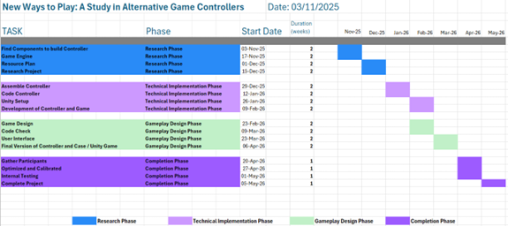
Figure 21. Gantt Chart Project Timeline

- Feasibility, Risks, and Ethical Aspects
B.1. Revised Feasibility
Choosing this project was a great choice because of prior knowledge about alternative controllers and existing code knowledge and working with hardware. The hardware and software that was used have good reputation and are easily accessible. Creating Gantt charts and in-depth planning to have the great story tot the project and have the best results possible by the end
B.2. Updated Risk Analysis and Mitigation
Potential Risk | Likelihood (Low/Med/High) | Impact (Low/Med/High) | Mitigation Strategy
Hardware malfunctioning, due to faulty electronic components  or damaged | Medium | High | Identify the best Components and researching previous user experiences to ensure best possible outcome.
Errors in the code when developing a seamless interaction between motion controller and Unity | Medium | Medium | Allocate time into  tutorials and guides and seeking guidance with supervisor.
Finding participants that are willing to take part in the project as test | Low | High | Look for individuals that are willing to take part in testing the product, online or real life early.
Table 4. Risk Assessment and Mitigation

B.3 Revised Ethical Considerations
During this project, there will be a lot of aspects of human interaction and having to make sure that the development of the project needs to be ethically considered, as well as how this can also be thought through. This project will ensure that the products being used are ethically sustainable, such as electronic components and Unity software that are free and at a low cost. The data handling will be done online as this is a much easier process. The project will follow academic guidelines and any information used will be correctly credited.
Furthermore, the data that was collected during the user testing will ensure its all consenting and will all be anonymous for the online forms as they weren’t asked to use emails or provide names and the consent forms that were signed before and after reading the information sheet will be kept private and can be accessed by them if they would like to withdraw.

References
Akyaman, S. & Cem Alppay, E., 2024. Effects of industrial design properties of game controllers on player experience. Entertainment Computing, May, Volume 50, p. 100687.
Madigan, J., 2015. Why we hate (some) video game motion controls. [Online]
Available at: https://www.psychologytoday.com/gb/blog/mind-games/201506/why-we-hate-some-video-game-motion-controls
[Accessed 29 April 2026].
Malone, L. A. et al., 2023. Usability of the GAIMPLANK video game controller for people with mobility impairments: Observational study. JMIR Serious Games, Volume 11, p. e38484.
Thorpe, A., Ma, M. & Oikonomou, A., 2011. History and alternative game input methods | IEEE conference publication | IEEE Xplore. [Online]
Available at: https://ieeexplore.ieee.org/document/6000321
[Accessed 29 April 2026].

